Frequency Topology of Encryption By Ricardo.gil@sbcglobal.net

12/10/2017

The objective of this paper is simplify frequency topology of encryption.

And represent Linear Graphs that can be represent in dimension 2 or greater.

1. Linear Graphs

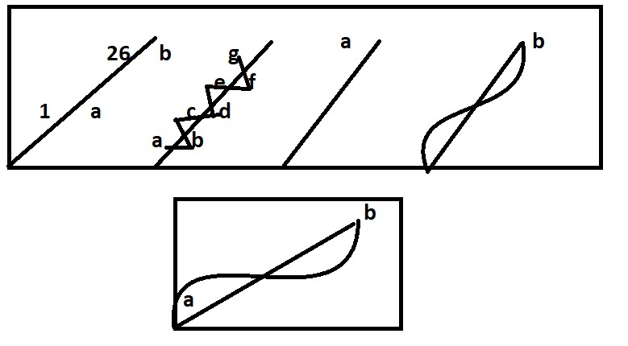

Note: 1=A/1=B/2 or A/1 =B/2=1

II.

import sys import math

from random import randint from functools import reduce from sys import getsizeof from mpmath import mp

A=1

B=2

C=3

D=4

E=5

F=6

G=7

M=(.07)\*(A)+(B)+(C)+(D)+(E)+(F)+(G) print(M)

#27.07

m=math.sqrt(M) print(m)

#27.07

#5.202883815731425

N=m # 5 Number2Text 5 = E

#Message is ABCDEFG

#(A+B+C+D+5+F+G/1+2+3+4+5+6+7)=1

III. Discussion

If one takes the alphabet and divides 2/26 on gets .07. In the Torah Mosses is

500. So with 3 Dreidels, one can create 500 or Mosses by adding 5 which is E and

O which is 15 . of 5,15,15= 35 but each letter is weighted .07 so Mosses becomes

5\* .07=.35, 15\*.07= 1.05and 15\*.07=1.05 grand total 2.45. Mosses equal 2.45. So Mosses =2.45 = 5+15+15= 35 =Mosses=5 0 0

1. 3rd dimension

[1(2\*\*2)+2(2\*\*2)+3(2\*\*2)+4(2\*\*2)+5(2\*\*2)=6(2\*\*2)]\*\*22/7(Pie) or the 3rd dimension

1. References

\*\*\* Ref Ordinary Lines Poonen

\*\*\*Ref Ordinary lines Tao & Green \*\*\*Ref Ricardo Gil Vixra.org

1. 299792458 digits

import os

import sys

import math

import scipy

import random

import numpy as np

from mpmath

import mp

mp.dps=299792458 # Einstein speed of light in the third dimension.

A=mp.mpf(22)

B=mp.mpf(7)

C=A/B

print(C)

1. 400000000 digits

import os

import sys

import math

import scipy

import random

import numpy as np

from mpmath

import mp

mp.dps=400000000 # Tesla speed of light in the fourth dimension.

A=mp.mpf(22)

B=mp.mpf(7)

C=A/B

print(C)